**Design: Inventory Management System**

Table of Contents

Introduction---------------------------------------------------------------------------------------------------- 3

Purpose and Objectives-------------------------------------------------------------------------------------- 4

Design---------------------------------------------------------------------------------------------------------- 5

GUI Diagram------------------------------------------------------------------------------------------------ 10

**Introduction**

Inventory Management Systems are essential to the daily operations of many organizations. The primary goal of inventory management is to assist businesses to manage the ordering, stocking, storing, and using of supplies conveniently and efficiently. The intent of the correct management of inventory is a fundamental pillar of achieving success in enterprises because it ensures that stocks of raw material or other supplies are maintained at levels that provide maximum service levels at minimum costs. An inventory management system for a store selling stationery and office supplies is currently being developed by the authors of this document. The application will consist of a graphical user interface (GUI) and data saved into a structured query language (SQL) database. This document will discuss the design for the inventory management system and a test plan.

**Purpose and Objectives**

The purpose of a design plan is to have an early phase of the project where the main features, structure, criteria for success, user interface and main objectives are all planned out. The goal is to develop a design that can be used to achieve the intended project desires. Programmers can then decide the most effective and efficient design to select for the fulfilment of the project. This project design phase generates a variety of different outputs, including, flowcharts, GUI design ideas, and class diagrams.

The objective of the design plan is to give the group of developers and any customers you are designing the application for a solid understanding of all the different features your application is going to contain. This includes the functionality of each of the features and how the user is going to interact with the application. During the design phase you want to be technical, but not so technical that an average user would have difficulty understanding most of the concepts involved.

**Design**

**Overview:**

*Product Description:*

For the inventory management system we are going to have a GUI that users will log into using a username and password that they create with role based access depending on their status in the company (Employee or Manager). After logging in, if they are a regular employee then they will have access to add, modify, search, and delete products and order information from the database. If they are a manager in the company then they will have the same ability as the employees in addition to being able to add, modify, and delete employee information, add system users, and pull reports from the database.

**Application Diagram:**

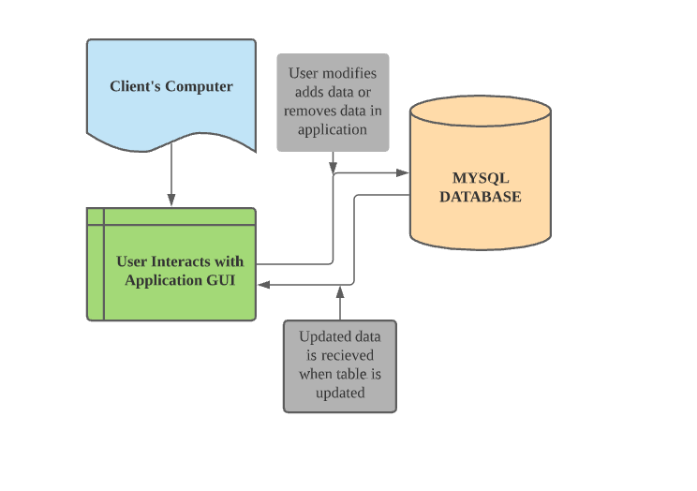

**UML Diagram of Application**

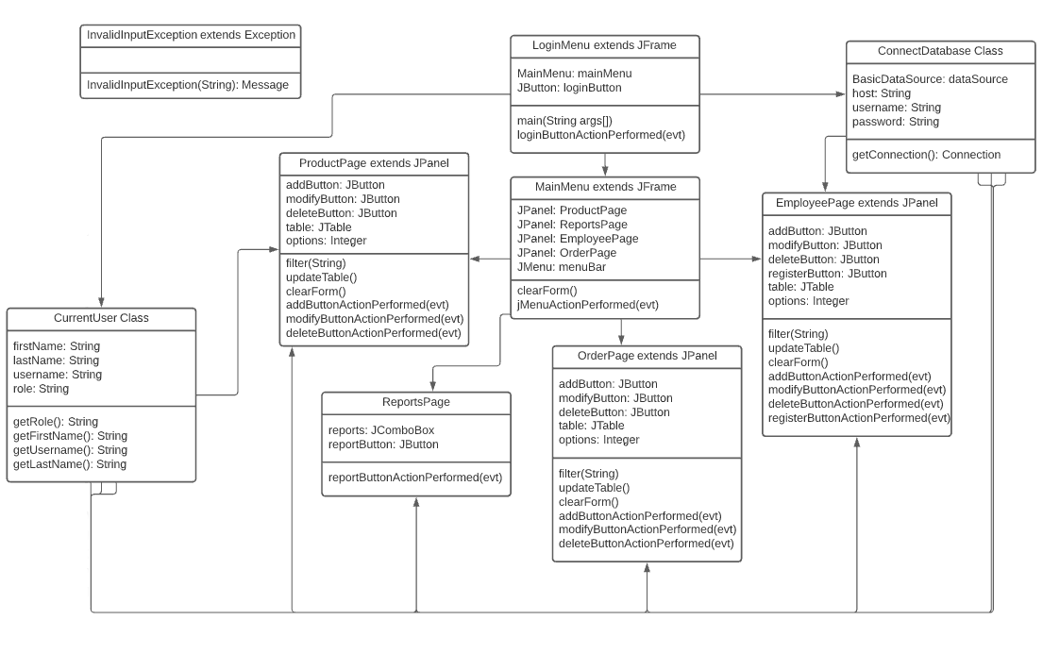

*Key Features:*

* Ability to create accounts
* Role based access
* Add, modify, search, and delete product/order/employee information from the database.
* Table for user to see all data in the database
* Login/logout functionality
* Ability to change user password
* Manager is able to pull reports for overview of data

*Main User Activities*:

1. If a user is an employee they will have access to add, modify, delete data from the products or order database. They will achieve this by clicking buttons and inputting data into text fields. Employees will have access to search the table for products or orders and reset the table to the original view. Employees will be able to select table rows and delete or modify them as necessary.
2. If a user is a manager then they will have access to every feature an employee has access to. Managers will be able to add new employees into the database to keep track of every employee working at the company. Managers will also be able to create accounts by searching for the employee they want to create an account for, clicking that employee row on the table, and then clicking the register button. Managers will also have access to generate reports for total product revenue, total employee salaries, and more.

*Subsystems:*

The application will work by interacting with a SQL database to store the data that the user inputs and make modifications to the data. The system will connect to the database using a connection pool class. This class will create a pool of connections ready to be used when a thread needs them to increase the performance of the application while decreasing the amount of resources the application will need to use. After a connection object is done being used, then it will be released back into the connection pool for the next thread that needs access to a connection. There will be a total of four tables in the database being Products, Orders, LoginInfo, and Employees.

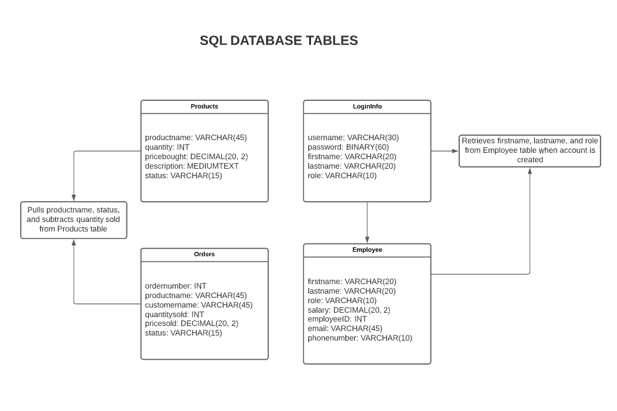

*Application Requirements:*

1. A SQL database server
2. Five java libraries are required for the application to run. These are commons-dbcp2-2.9.0.jar, commons-logging-1.2, commons-pool2-2.11.1, jBCrypt-0.4.1, and mysql-connector-java-8.0.27.
3. The application jar file

**Design Considerations:**

*Operational Environment:*

For this application we will mainly be working in a java IDE. Our group will be sharing important documents and latest coding updates through a google drive shared folder. We will be discussing updates and progress on the application through weekly meetings on a discord server.

*Development Methods:*

We will be creating the GUI interface for the user using java’s swing library. The application will connect to the database using a database connection pool class to open and close connections as they are needed. The current logged in user will be stored in the current user class after the user has logged into the application. The table presented to the user will be constantly updated every time a user makes a change to the database.

*GUI Layout:*

The user will first be presented with a login page where they will enter their username and password. Once a user is logged in successfully they will be presented with the main menu of the application. From here they will be able to navigate to the Products or Orders pages. If the user is a manager then they will have the option to also navigate to the Employees and Reports pages. There will be a menu bar at the top of the main menu with the current logged on user being displayed. The user will be able to click on the current logged on user and a drop down will appear to change their password or log out of the application. There will also be an option to exit the application on the menu bar.

**GUI Diagram**

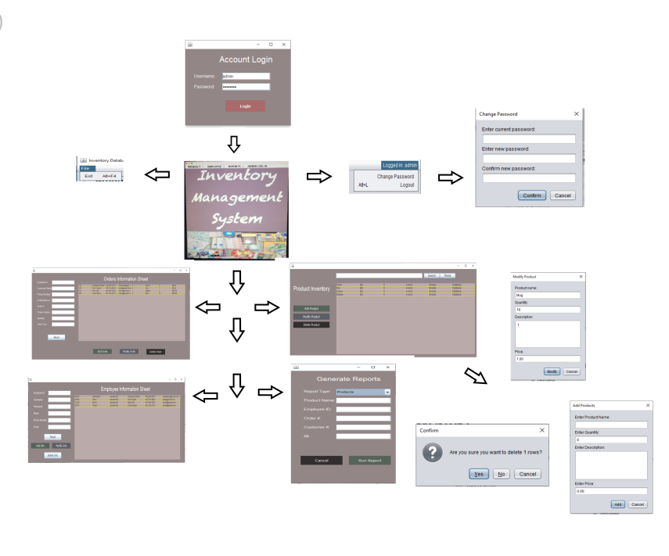

*(Diagram Subject to Change)*